## Team Members

**SRI VISHNU. M :** [**srivishnu1103@gmail.com**](mailto:srivishnu1103@gmail.com)  **(Team Leader)**

**SATHIS KUMAR. G :** [**g.sathiskumar22@gmail.com**](mailto:g.sathiskumar22@gmail.com)

**SANJAY KUMAR. R :** [**rsanjaykumar1319@gmail.com**](mailto:rsanjaykumar1319@gmail.com)

**MOHAMMED NOORULLA. S :**

**noorullasnoorul123@gmail.com**

Fake News Detection Using NLP

The following figure illustrates the flow or the process or the steps involved in the fake news detection.

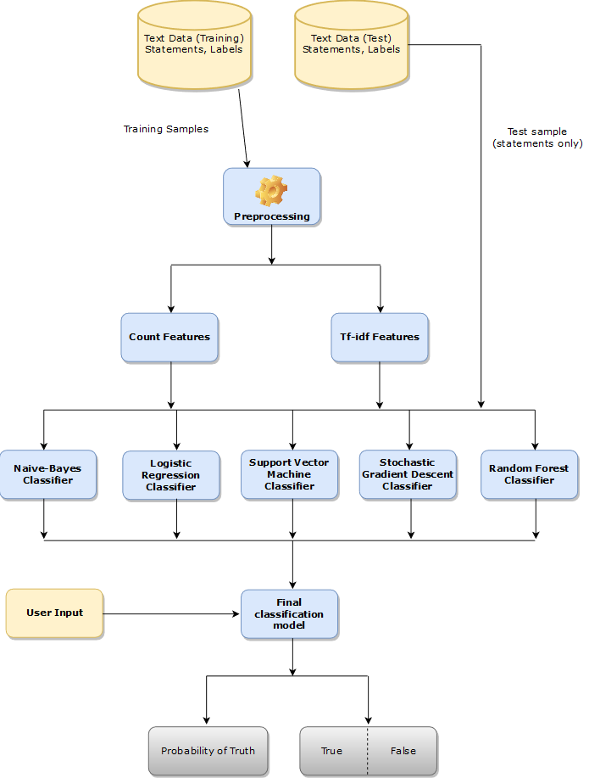

Fake news detection process

1. Data Collection:

Gather a diverse dataset of news articles, including both real and fake news, to train and test your model.

2. Text Preprocessing:

Text preprocessing involves transforming text into a clean and consistent format that can then be fed into a model for further analysis and learning.

3. Feature Extraction:

Convert text into numerical features. Common methods include TF-IDF (Term Frequency-Inverse Document Frequency) and word embeddings like Word2Vec or Glove.

4. Model Selection:

Choose an appropriate machine learning or deep learning model. Common choices include Logistic Regression, Random Forest, Support Vector Machines, Naive baye’s classifier, Stochastic gradient descent and neural networks like LSTM or BERT.

5. Model Training:

Train your selected model on the preprocessed data, using labelled examples of real and fake news.

6. Model Evaluation:

Use evaluation metrics like accuracy, precision, recall, F1-score, and ROC-AUC to assess the model's performance on a separate test dataset.

7. Fine-Tuning:

Experiment with hyper parameters and model architectures to optimize performance.

8. Cross-Validation:

Implement cross-validation techniques like k-fold cross-validation to ensure your model generalizes well.

9. Post-processing:

Apply additional techniques like thresholding or ensemble methods to refine predictions.

10. Real-time Monitoring:

If deploying for real-time monitoring, set up a system to continuously analyze incoming news articles and classify them as real or fake.

11. User Interface:

Develop a user-friendly interface or application for users to check the authenticity of news articles.

12. Updates and Maintenance:

Regularly update your model with new data to adapt to involving fake news tactics.

13. Ethical Considerations:

Consider the ethical implications of your fake news detection system, such as biases in the data and model, and take steps to mitigate them.

# Conclusion:

The final model classifier is derived from combining the other classifiers such as random forest, support vector machine classifier, stochastic gradient descent, naive bayes classifier, logistic regression classifier. When the user give input to this final model classifier, this model classifies the probability of the input or to determine whether the given input news is true or fake.